Drop off Process for GET YOUR REFUND
Follow the link to the Northland Free Tax Assistance Get Your refund site:
https://www.getyourrefund.org/nfta
Step 1: click the Get Started Button
Step 2: click on File taxes with help
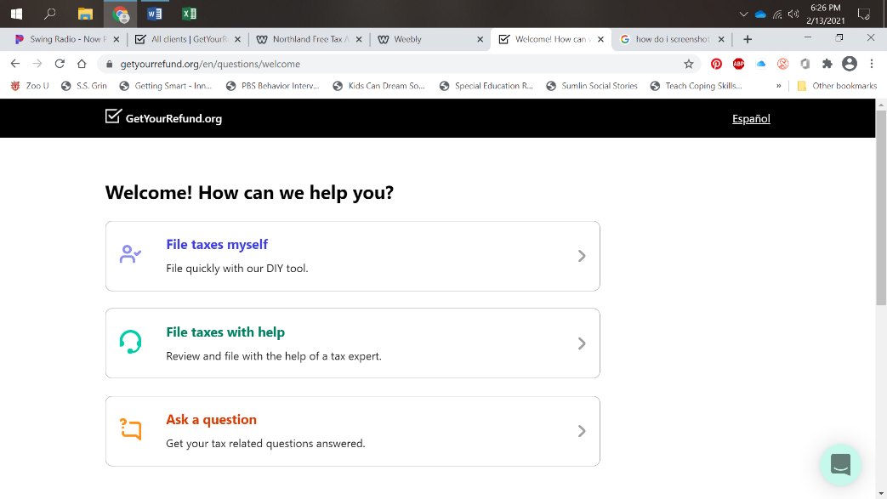
Step 3: click continue
Step 4: select the year or years you need to file.
2017, 2018, 2019, or 2020
Step 5: click continue
Step 6: answer eligibility questions, then click continue
Step 7: information sheet on upload and process, click continue
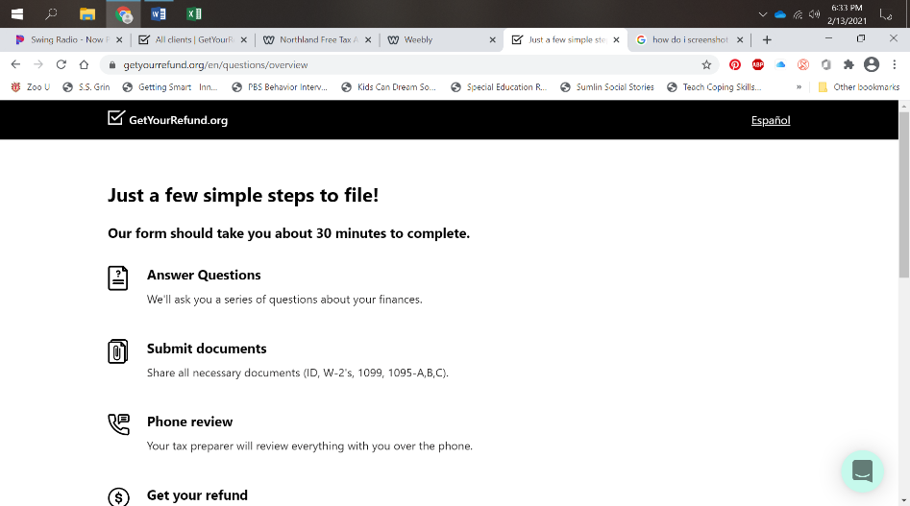
Step 8: complete intake questions and uploads
Items you will need to complete the upload: Please make sure you have all documents scanned or pictures on your computer before you begin to answer questions as it will make the process faster.
As you go through the website and answer the questions and fill out your information you will also need to have copies of certain tax documents, social security cards for all members you claim on your return, and ID’s for you and your spouse. You will need to upload all these documents as you fill out and answer questions relating to your tax situation.
Copies you will need to upload:
Your and your spouse’s ID
Copies of your Social Security or ITIN Cards for everyone whom you claim on your return
A selfie of you holding your ID for you and your spouse
Any tax documents: w-2s, 1099s, 1098s, 1095s, Social Security or Disability 1099s, w-2G
If you plan to itemize copies of your itemizing category totals
If you are self-employed: list of business expenses, including vehicle info and mileage for claiming use of vehicle for self-employment.
Bank routing and account number if doing direct deposit
Step 9: Once you complete the uploads and questions, you will be put in the que for screening
Step 10: A screener from Northland Free Tax Assistance will contact you via email or text to set up a phone call to complete your screening. Secure contact from Numbers or email addresses from Get Your Refund to look out for are:
- texts from: 58750
- emails: hello@getyourrefund.org
- phone calls from: 1-650-449-4147
Step 11: Once your screening is complete and all other necessary information has been uploaded, your return will be prepared and a preparer may reach out to you with any extra questions.
Step 12: Once your return is complete you will be contacted to complete the Quality review and sign your 8879s – permission to e-file your returns. Once signed, your return will be filed. Once accepted an acceptance email will be sent.

